Week3 Day3 screenshots

Leytion Exc 4

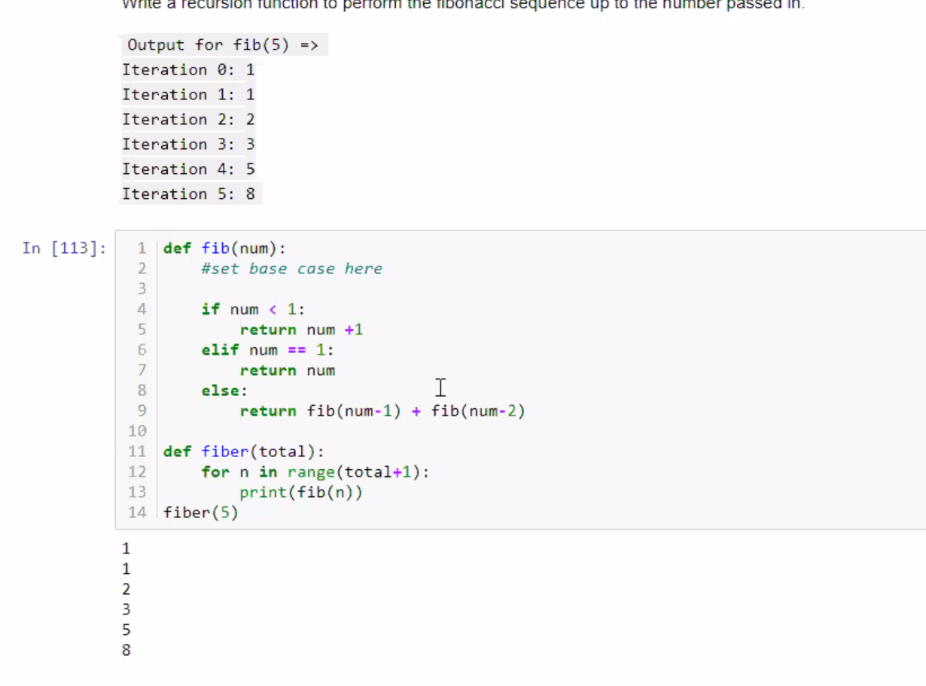

Joels solutions to day 2 Excersises

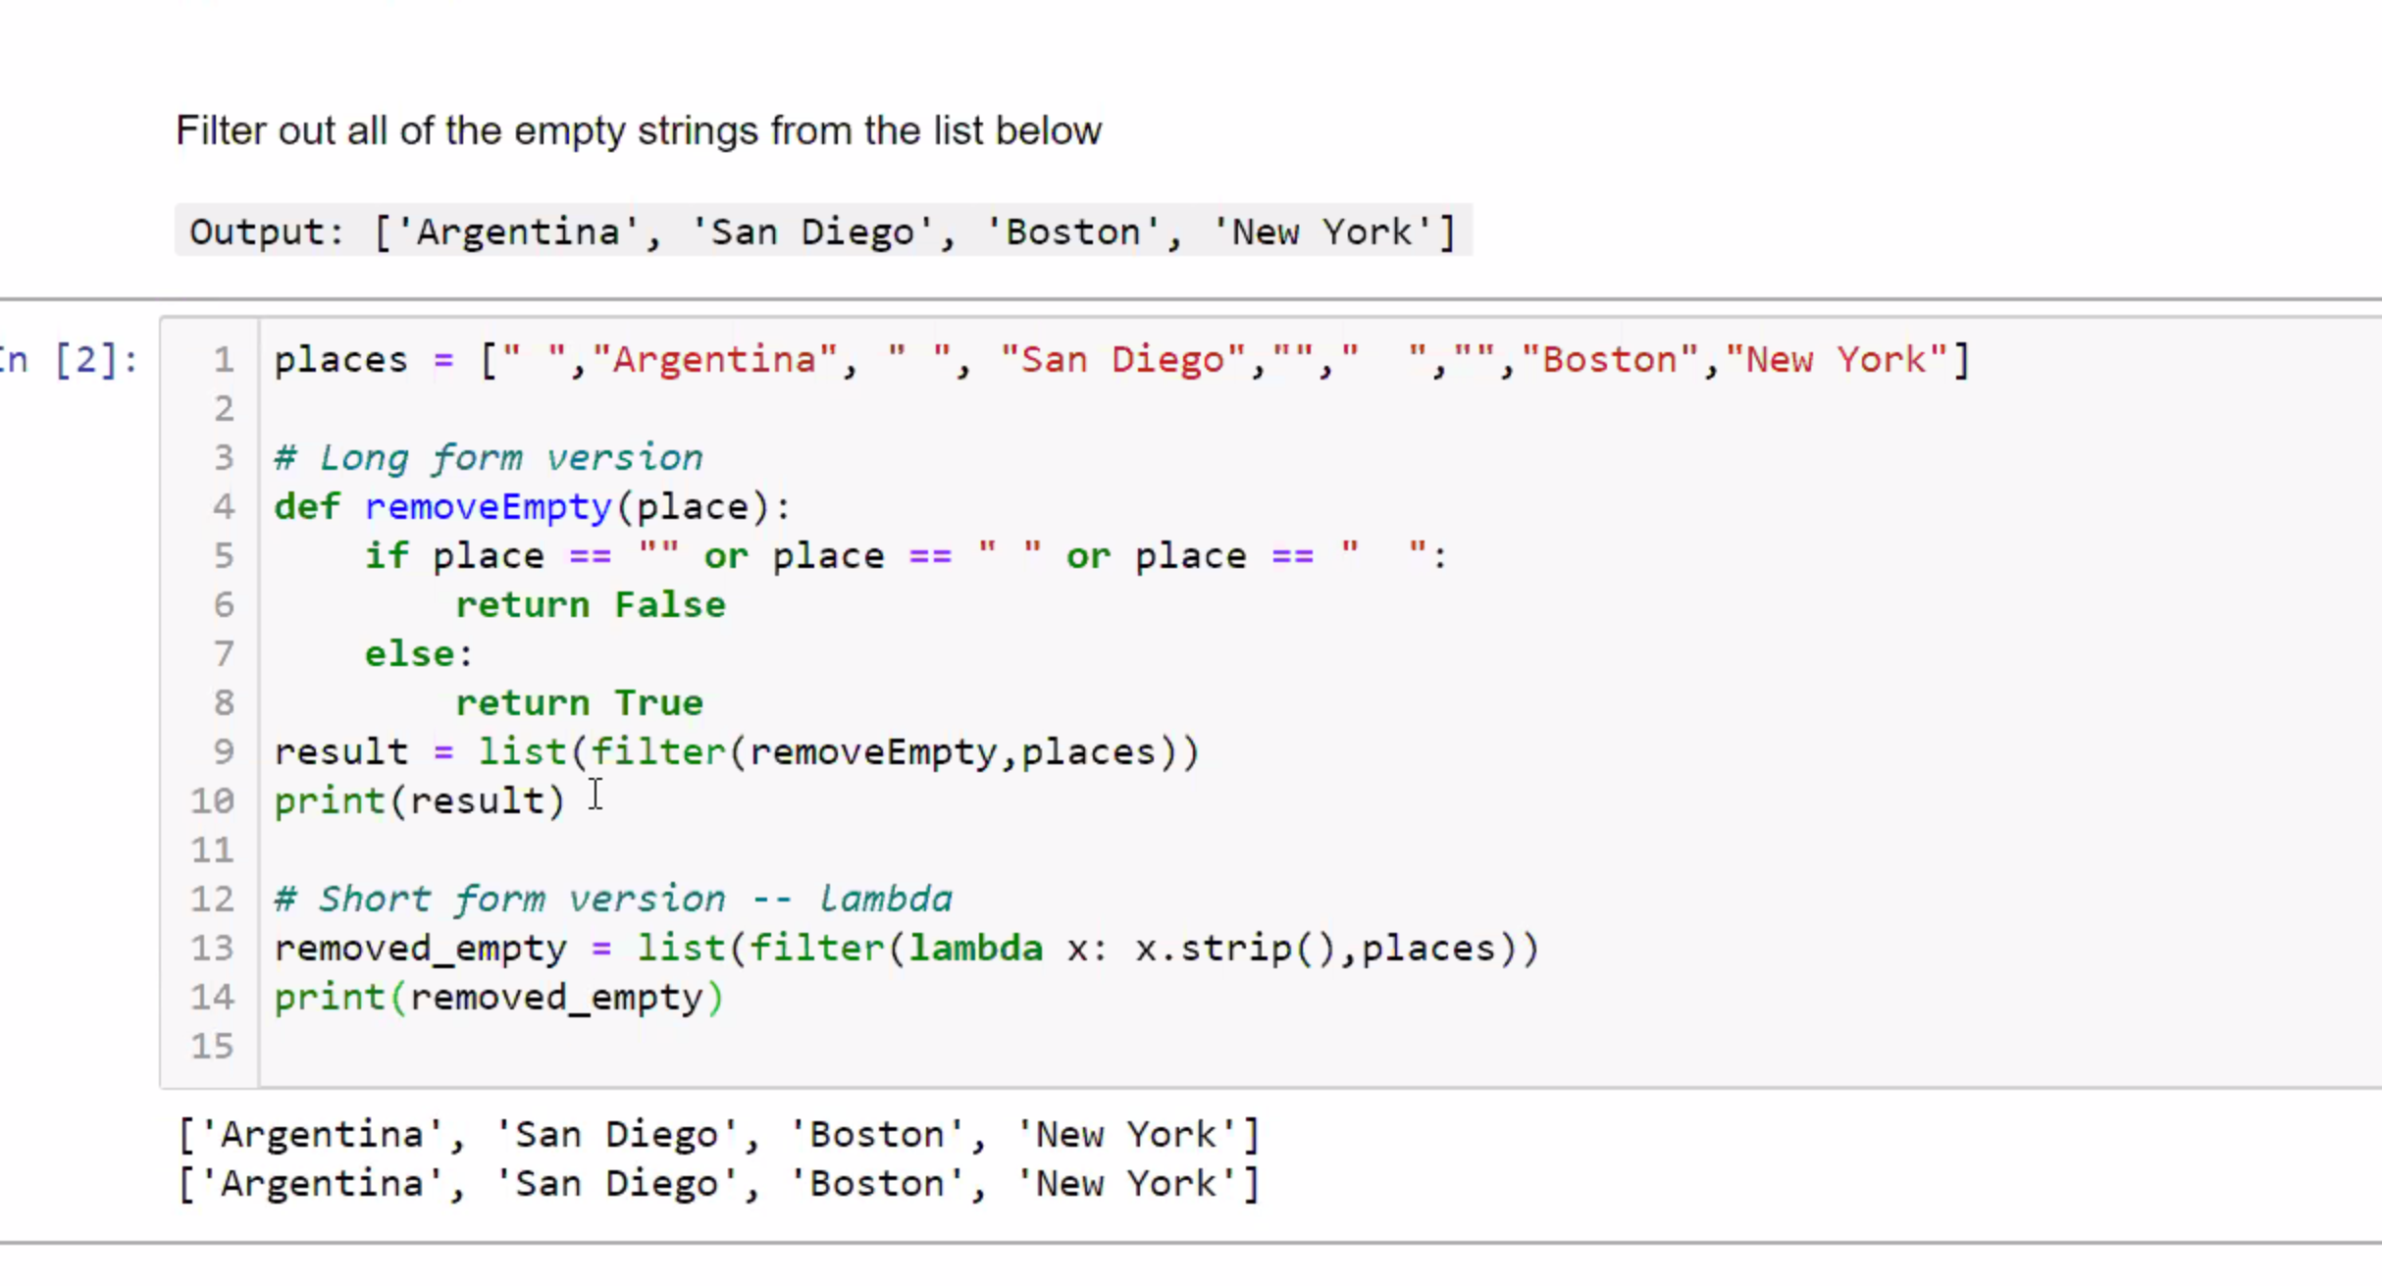

Exercise 2

Sort is already using indexes

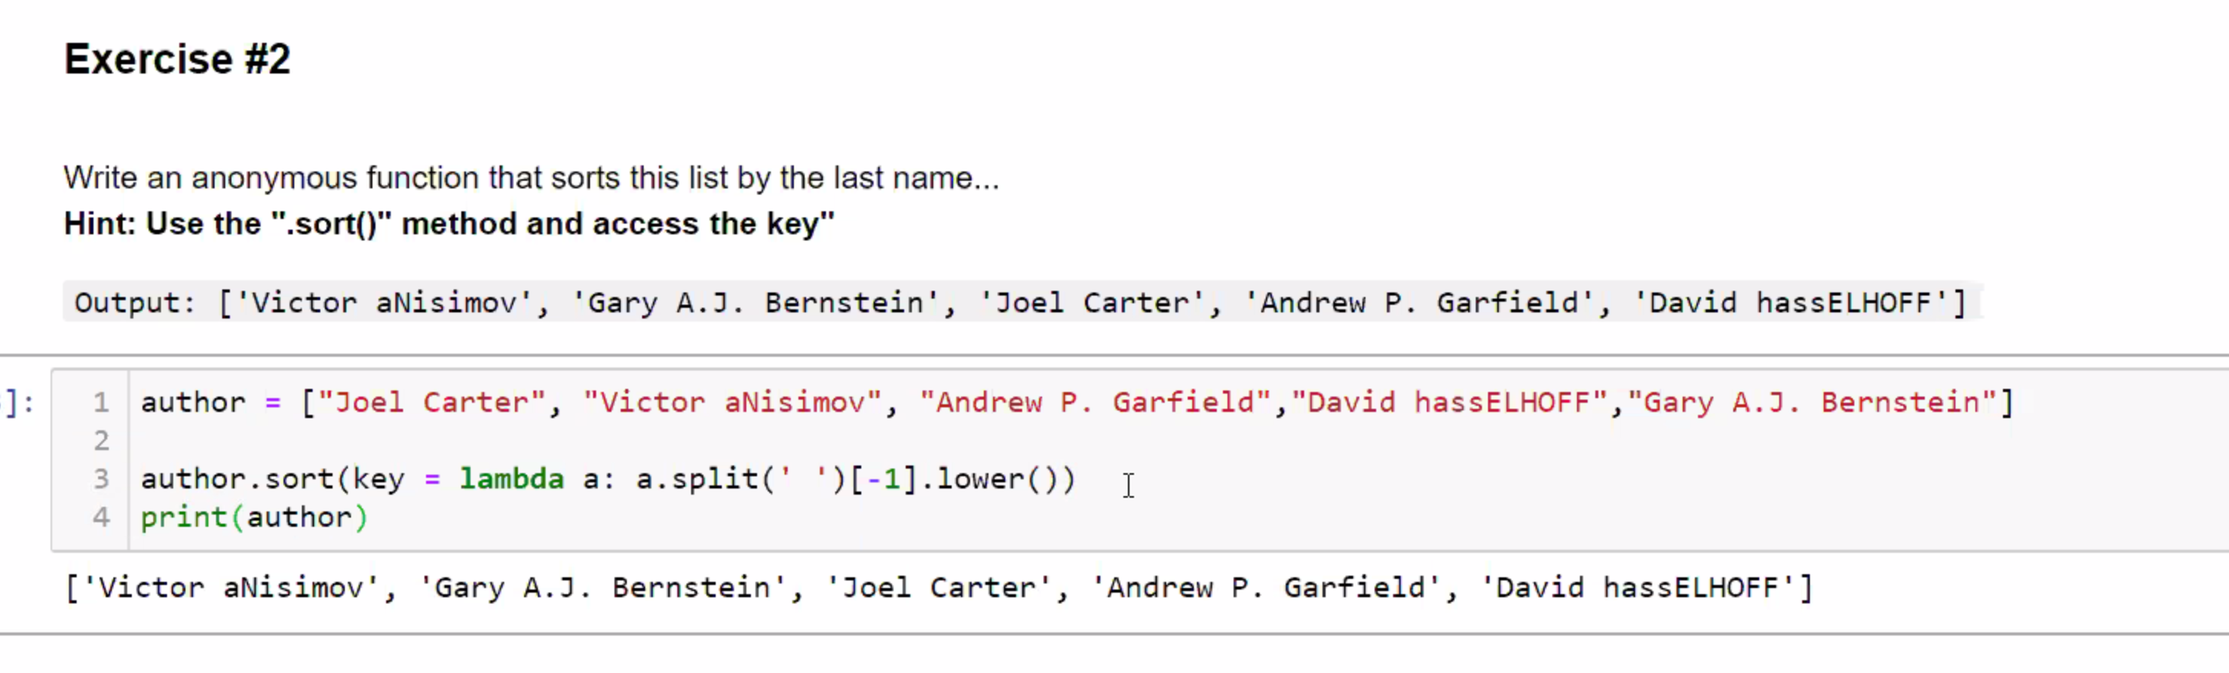

Split turns the string into a list

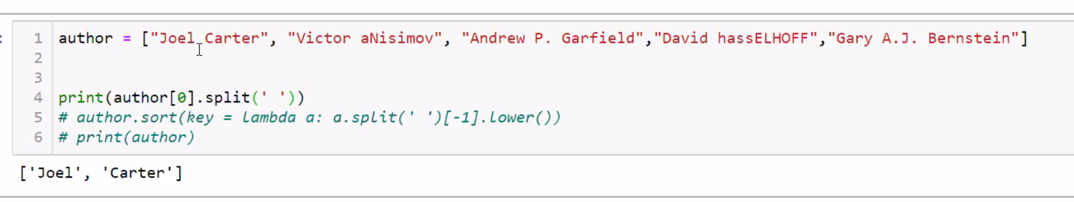

Then

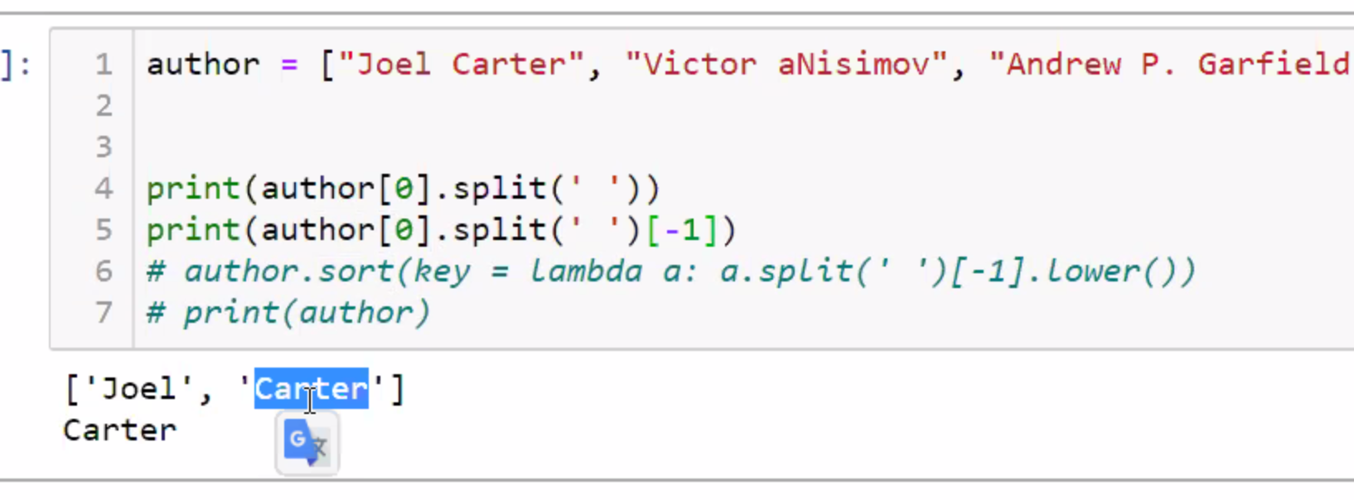

Map lets you go into each index, keep eveything in place with the tuple indexes and map let you got into each index and grab the temp

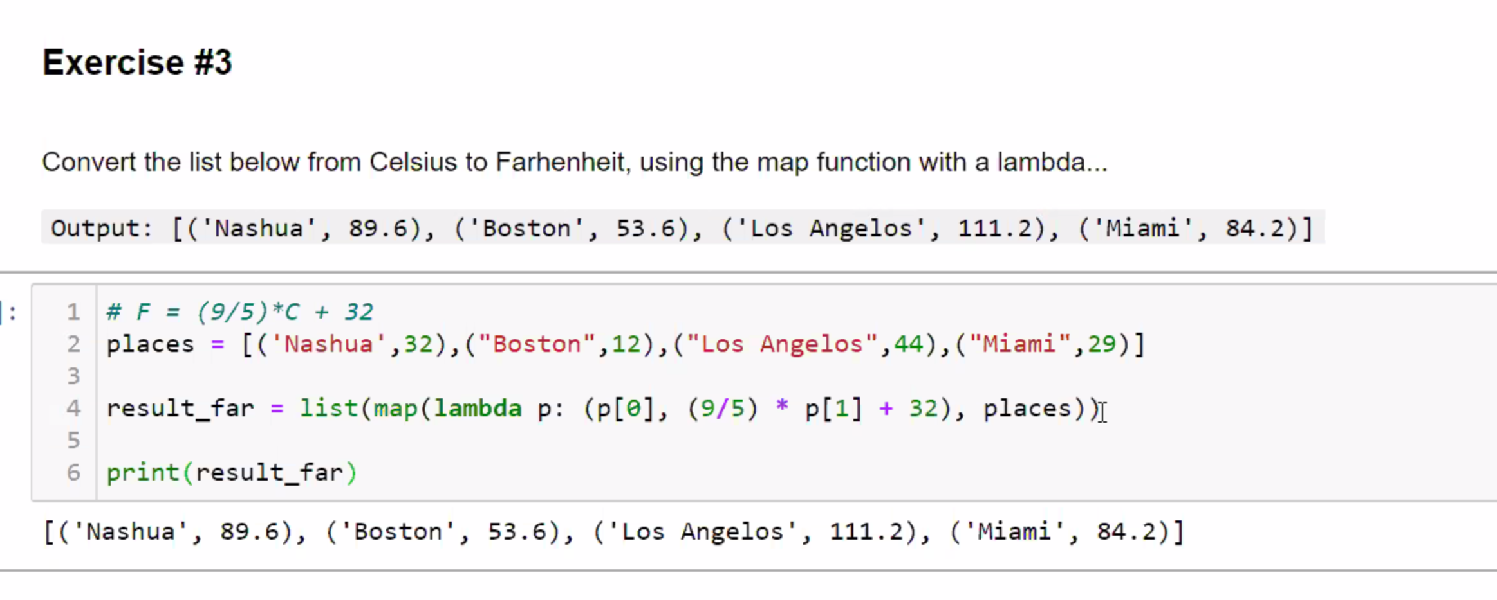

Excersise4

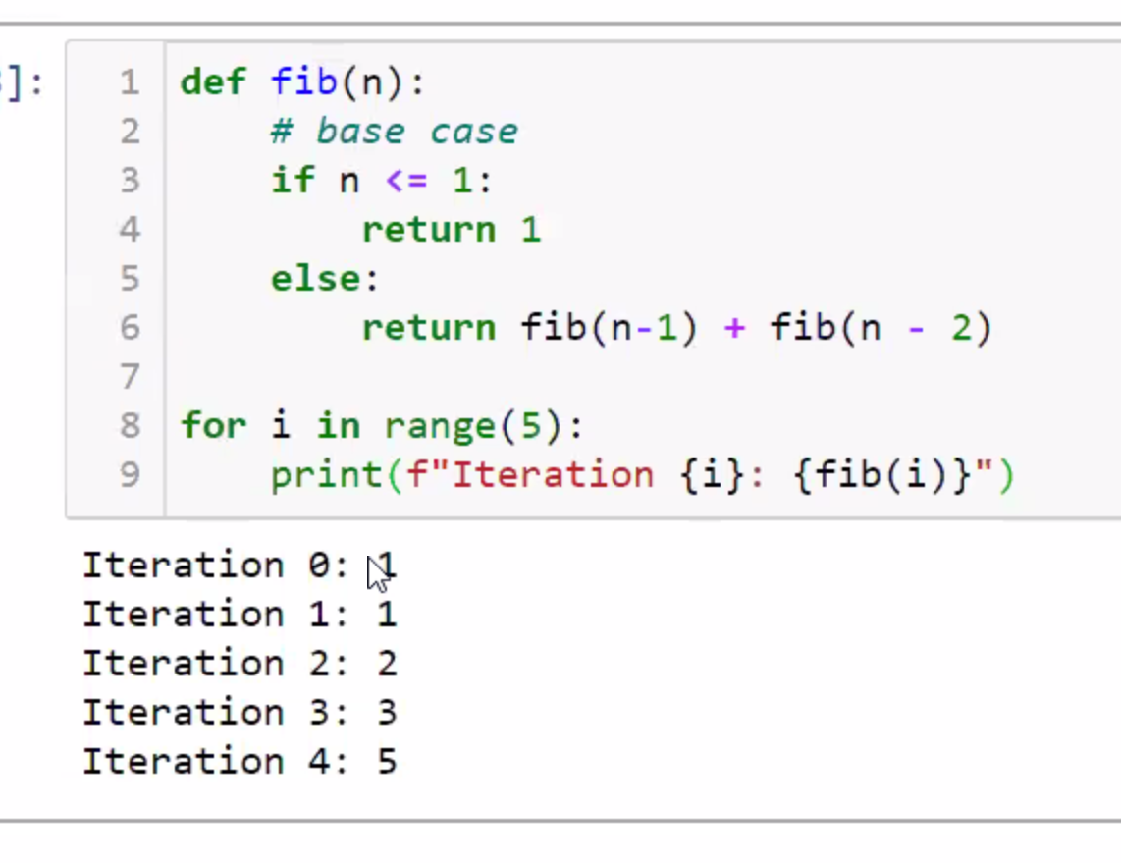

# Under the hood in In-Place algorithms

Chunk of RAM with memory slots, comp put my list values in 3,4, and 5 memory locations

Anytime you do a swap , inside the chunk of memory m you swap the values at the same location

**Before swap**

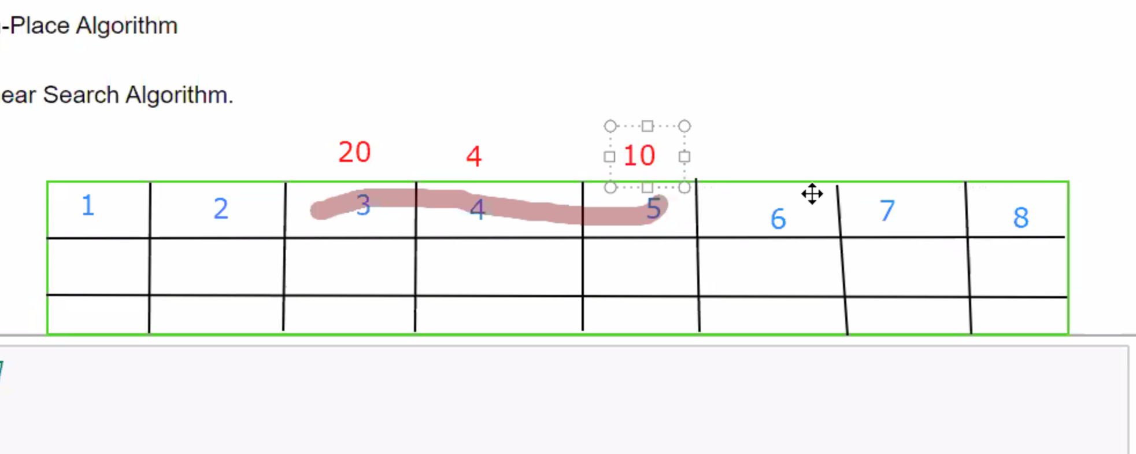

**AFTER SWAP**

Taking up the same memory location, don’t need to take and additional memory, constant space

How well an algorithm based on Time and space complexity, how many variables do I have to use to solve the problem.

Any this done in constant space is the ??? in Big O notation is 01 - CONSTANT

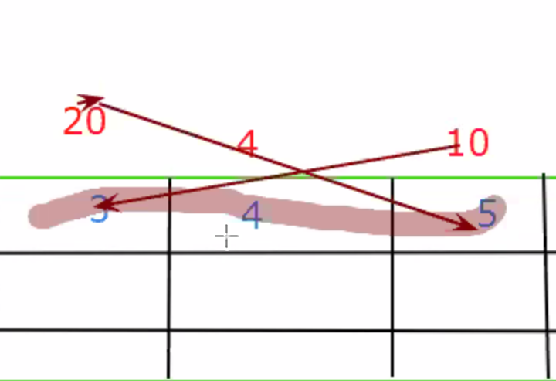

# OUT OF PLACE ALGORITHM

My list = [10,4,20] in on 3,4, and5, memory slots

Python copies them down to another spot

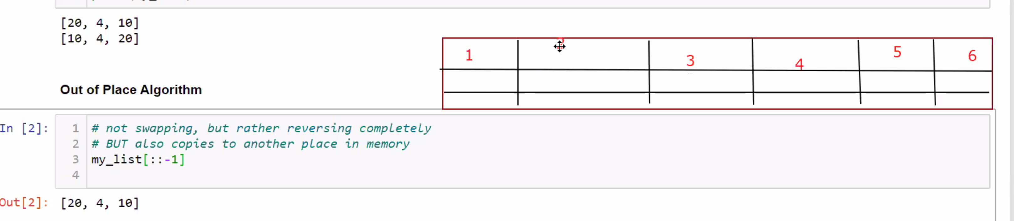

Python copies them down to other spots in memory, this is done in linear space, once we copy them down then we can swap them

If you need to reverse a string or list, if you use [: : -1] you are using linear space . this is only in python, it is the way it reverses things

# Interview question

If you use the Python does this in a copy and reverse method so it uses linear space

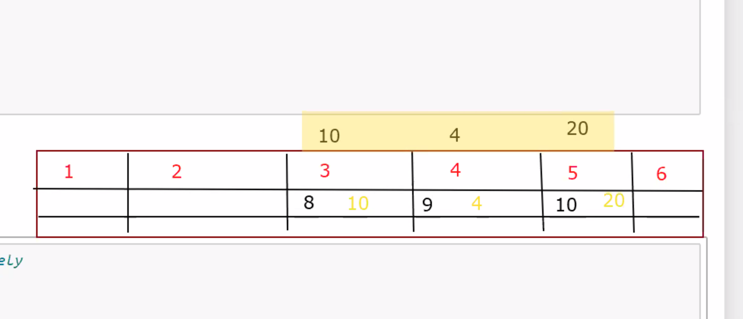

Excer

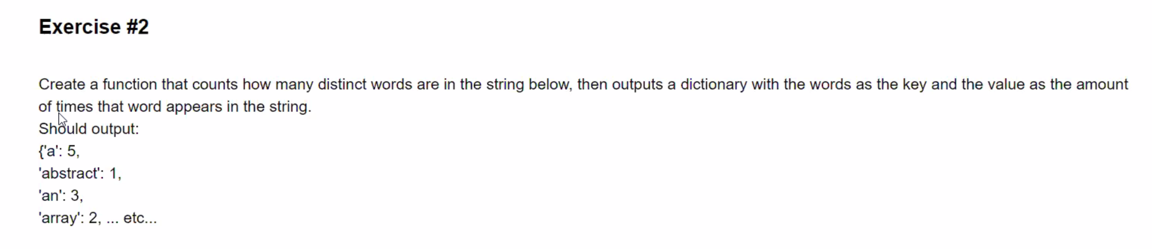

Fixing github names in

